UNITED STATES SECURITIES
AND EXCHANGE COMMISSION
WASHINGTON, D.C. 20549
SCHEDULE 14A
Proxy Statement Pursuant to Section 14(a) of the Securities Exchange Act of 1934
(Amendment No.)
Filed by the Registrant [x]
Filed by a Party other than the Registrant [ ]
Check the appropriate box:
[ ] Preliminary Proxy Statement
[ ] Confidential, for Use of the Commission Only (as permitted by Rule 14a-6(e)(2))
[ ] Definitive Proxy Statement
[x] Definitive Additional Materials
[ ] Soliciting Material Pursuant to §240.14a-12
U-Haul Holding Company
(Name of Registrant as Specified in Its Charter)
(Name of Person(s) Filing Proxy Statement if Other Than the Registrant)
Payment of Filing Fee (Check the appropriate box):
[x] No fee required
[ ] Fee paid previously with preliminary materials
[ ] Fee computed on table in exhibit required by Item 25(b) per Exchange Act Rules 14a-69i)(1) and 0-11


Your Vote Counts! U-HAUL HOLDING COMPANY 2023 Annual Meeting Vote by August 16, 2023 11:59 PM ET. For shares held in a Plan, vote by August 14, 2023 11:59 PM ET. U-HAUL HOLDING COMPANY C/O U-HAUL INTERNATIONAL, INC. ATTN: LEGAL DEPARTMENT 2727 N. CENTRAL AVE PHOENIX, AZ 85004 V20460-P96632 You invested in U-HAUL HOLDING COMPANY and it’s time to vote! You have the right to vote on proposals being presented at the Annual Meeting. This is an important notice regarding the availability of proxy material for the stockholder meeting to be held on August 17, 2023. Get informed before you vote View the Notice, Proxy Statement and Annual Report online OR you can receive a free paper or email copy of the material(s) by requesting prior to August 3, 2023. If you would like to request a copy of the material(s) for this and/or future stockholder meetings, you may (1) visit www.ProxyVote.com, (2) call 1-800-579-1639 or (3) send an email to sendmaterial@proxyvote.com. If sending an email, please include your control number (indicated below) in the subject line. Unless requested, you will not otherwise receive a paper or email copy. For complete information and to vote, visit www.ProxyVote.com Control #Smartphone users Point your camera here and vote without entering a control number Vote in Person at the Meeting* August 17, 2023 9:00 AM PDT Shoen Family Conference and Fitness Center 45 E. Roanoke Rd. Phoenix, AZ 85004 and webcast at http://investors.uhaul.com*Please check the meeting materials for any special requirements for meeting attendance. At the meeting, you will need to request a ballot to vote these shares. V1.2

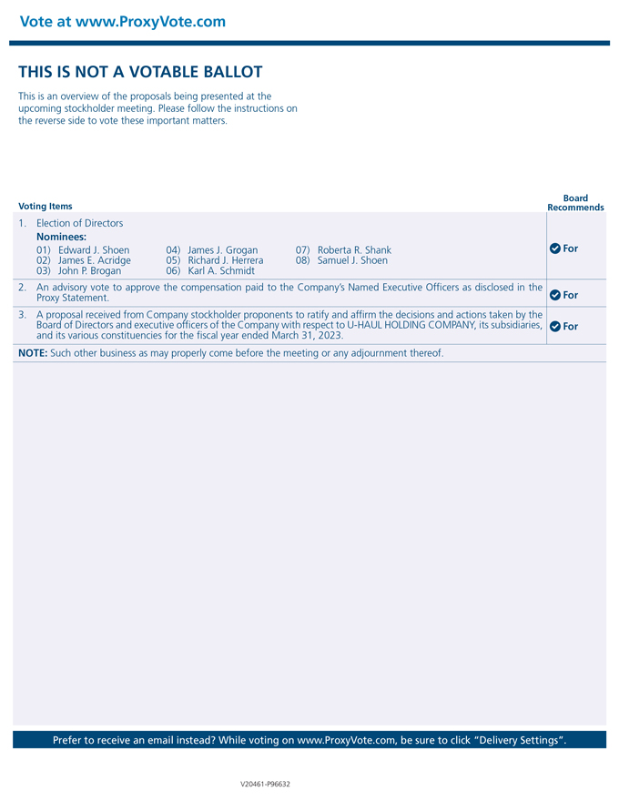
Vote at www.ProxyVote.comTHIS IS NOT A VOTABLE BALLOT This is an overview of the proposals being presented at the upcoming stockholder meeting. Please follow the instructions on the reverse side to vote these important matters. Voting Items Board Recommends V20461-P96632 For For For 01) Edward J. Shoen 02) James E. Acridge 03) John P. Brogan 04) James J. Grogan 05) Richard J. Herrera 06) Karl A. Schmidt 07) Roberta R. Shank 08) Samuel J. Shoen 1. Election of Directors Nominees: 2. An advisory vote to approve the compensation paid to the Company’s Named Executive Officers as disclosed in the Proxy Statement. 3. A proposal received from Company stockholder proponents to ratify and affirm the decisions and actions taken by the Board of Directors and executive officers of the Company with respect to U-HAUL HOLDING COMPANY, its subsidiaries, and its various constituencies for the fiscal year ended March 31, 2023. NOTE: Such other business as may properly come before the meeting or any adjournment thereof. Prefer to receive an email instead? While voting on www.ProxyVote.com, be sure to click “Delivery Settings”. V20461-P96632

