UNITED STATES SECURITIES
AND EXCHANGE COMMISSION
WASHINGTON, D.C. 20549

SCHEDULE 14A

Proxy Statement Pursuant to Section 14(a) of the Securities Exchange Act of 1934
(Amendment No.)

Filed by the Registrant [x]
Filed by a Party other than the Registrant [ ]

Check the appropriate box:
[ ] Preliminary Proxy Statement
[ ] Confidential, for Use of the Commission Only (as permitted by Rule 14a-6(e)(2))
[ ] Definitive Proxy Statement
[x] Definitive Additional Materials
[ ] Soliciting Material Pursuant to §240.14a-12

AMERCO
(Name of Registrant as Specified in Its Charter)

(Name of Person(s) Filing Proxy Statement if Other Than the Registrant)

Payment of Filing Fee (Check the appropriate box):
[x] No fee required.
[ ] Fee paid previously with preliminary materials:
[ ] Fee computed on table in exhibit required by Item 25(b) per Exchange Act Rules 14a-69i)(1) and 0-11

Notice Card 1 of 2

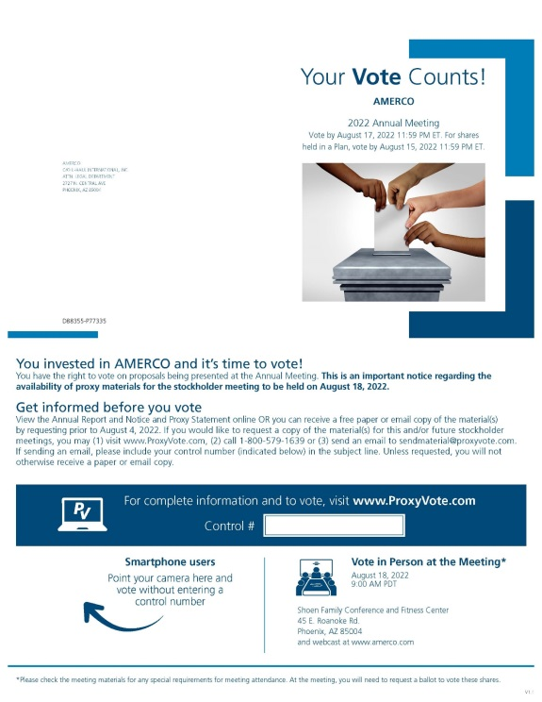

Notice Card 2 of 2

